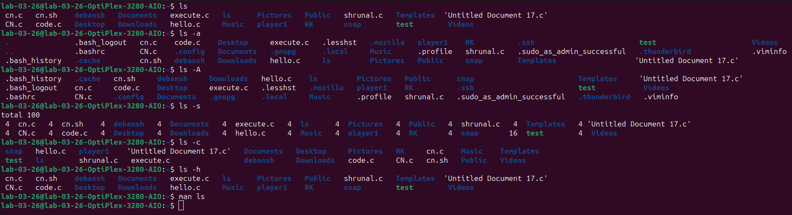
LS: a, A, s, c, h

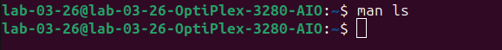
MAN LS: Manual Command

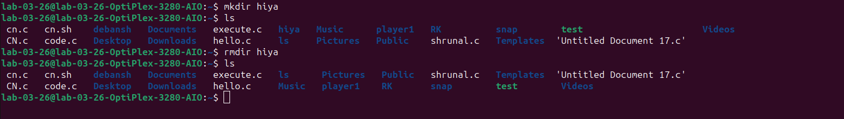
MKDIR: Make Directory & RMDIR: Remove Directory

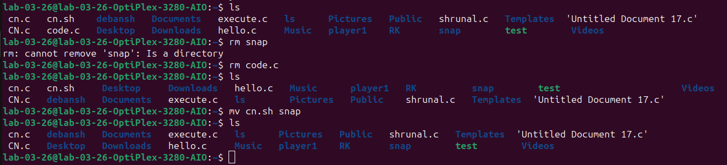
MV & RM: Move and Remove Command
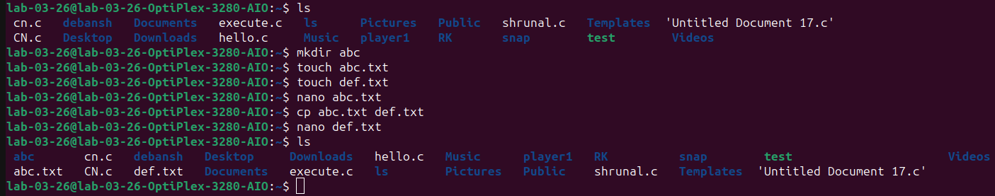
TOUCH & CP: Touch and Copy command

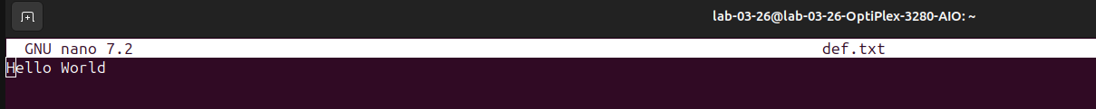
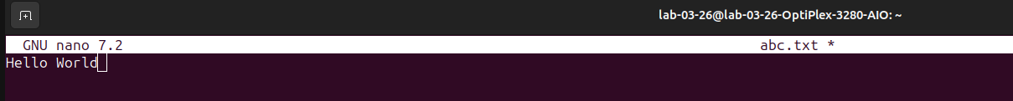
NANO command:

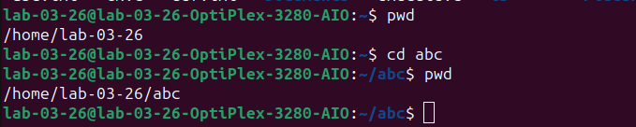
PWD & CD: Print Working Directory & Change Command
CAT: Concatenate Command
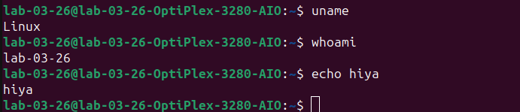
UNAME, WHOAMI, ECHO Commands

